Description Periodicity functionalities

This file just present how to use the functionalities for the periodicity included in PPMaP software. Once you open the mapping window. you will realize there are new item as shown in Fig 1 below in the green scare. Check at the Button as show by the red arrow if you want to consider the periodicity (**Fig 1**).

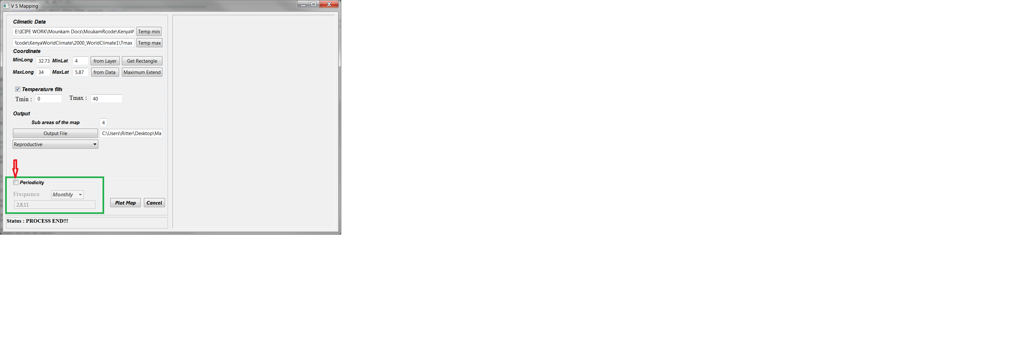

Figure 1: New mapping window

Once checked, you have to choose (**Fig 2 below**)

* (2) The Frequency of the periodicity (Monthly or weekly)
* (3) Enter the number of the months(for monthly) of the weeks( for weekly) of interest separated by a comma (I still have to write a code to control the conformity of what the use enter; i will do it later).

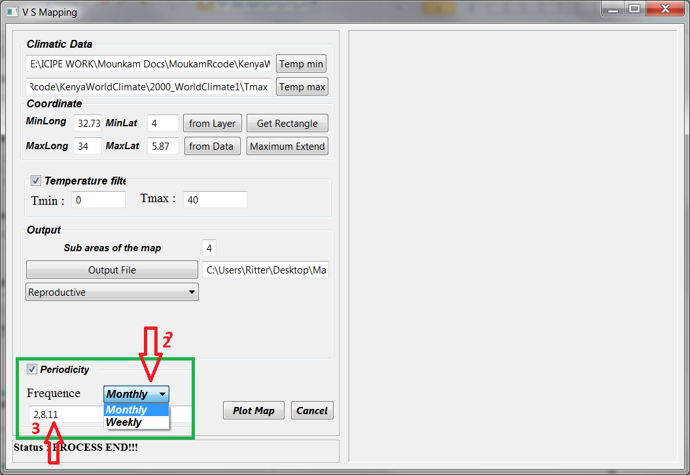

Figure 2: selection of the frequency